May 7, 2021 DRAFT

Draft of planned letter on behalf of NPA Parking Consultants Council. Members of NPA and IPMI have my permission to edit the text and submit on their own letter head to FHWA. The link for the submittal is in the PDF presentation.

Stephanie Pollack

Acting Administrator (HOA-1)

Federal Highway Administration

1200 New Jersey Avenue, SE

Washington DC 20590

Re: Comments on Notice of Proposed Amendment for Proposed 11th Edition of the Manual on Uniform Traffic Control Devices (MUTCD)

Dear Acting Administrator Pollack:

I am writing to offer comments on the December 14, 2020 Notice of Proposed Amendment (NPA) for the proposed 11th Edition of the Manual on Uniform Traffic Control Devices (MUTCD) on behalf of the Parking Consultants Council of the National Parking Association. The NPA Parking Consultants Council (PCC), formed in 1972, is the prestigious, peer-reviewed group of over 40 vetted parking consultants with a substantial body of work experience and references within the parking industry. The Council is comprised of architects, engineers and parking management consultants. In addition, there are affiliate members who represent vendors in the parking industry, including several involved in parking guidance systems. The PCC fosters information sharing on standards, regulations and trends that impact parking construction, management and operations. It develops best practices and technical educational manuals on parking industry topics. I was designated as a representative of the PCC, as well as the National Parking Association and the International Parking and Mobility Institute, to the National Committee on Uniform Traffic Control Devices (NCUTCD) committee on Sites Open to Public Travel.

The parking industry appreciates the purpose of the MUTCD, and endorses the concept of uniformity of traffic control devices for the public right-of-way as well as Site Roadways Open to Public Travel (SROPT). We appreciate the continued exception for parking facilities from the requirements of the MUTCD and many do use MUTCD guidance for the design of TCDs in parking facilities. We recognize the effort it takes to update MUTCD, and agree with the Institute of Transportation Engineers (ITE) sentiment, in their published comments dated May 5 2021, that it should be updated now, even as many believe that further changes than currently contemplated in the NPA are warranted. A clear example is that we believe that MUTCD standards for EV Charging signs are needed now, before the number of such stations explodes over the next decade. We therefore strongly recommend that the D9-11b symbol be used in the R7-112 and R7-114 series signs in the 11th edition of NCUTCD, as further discussed herein.

On behalf of the Parking Consultants Council, thank you for the opportunity to provide our comments on the NPA. Our detailed comments are contained in the following attachment.

Sincerely,

Mary S Smith

Senior Vice President, Walker Consultants

Chair, PCC MUTCD committee

**NCUTCD Recommendations on provisions for SROPT**

It appears that most of the NCUTCD recommendations regarding SROPT have been adopted. We further support adoption of two that were not apparently included.

1. Paragraph 2B.18: Recommend that this language be added to MUTCD. The MUTCD already has exceptions for stop signs within parking (under the premise that compliance with MUTCD is a should not a must in parking.) Putting it here helps clarify when a roadway through parking is considered a SROPT but has adjoining parking aisles that are not required to comply with MUTCD.

At the junction of two private roadways open to public travel, when the operating speeds are less than 25 mph on both roadways, a STOP or YIELD sign may be installed at a location on other than the right-hand side as necessitated by physical constraints. At the ends of driving aisles connecting to site roadways open to public travel, the word STOP on pavement when accompanied with a stop line may be used in place of the STOP sign.

1. Section 2B.03 - this text was not included in the NPA but we understand the NCUTCD Council is recommending it be included in the final version.

The minimum sign size for the site roadways open to public travel with operating speeds less than 25 mph may be 6 inches less in both width and height than the single-lane conventional road size except for supplemental plaques identified as “P” in the sign designation in Table 2B-1.

**Comments on Figure 2B-24**

* Sheet 1 of 2:
  + - New R7-113aP and R7-113bP: We recommend that these be put with the remaining R7-113 series signs on sheet 2 of 2, and that the color be green not black, for consistency with other parking regulation signs, such as the R7-8 accessible parking sign.
    - R7-21 and R7-22: As the industry that actually administers on-street parking, we strongly recommend keeping the term Pay Parking that was used on the 2009 R7-21 and 22 signs, rather than “metered parking”. The industry is moving away from meters and agencies are eliminating meters altogether and going to 100% pay by phone and other technologies. The placard R7-21P is needed, but is not adequate as the only sign, if there is no meter. We understand the NCUTCD is also recommending use of Pay Parking rather than “Metered.”
* Sheet 2 of 2:
  + R7-112 and 114 series of Electric Vehicle Charging Signs. We strongly recommend use of the EV charging symbol D9-11b on signs for EV charging. We disagree that the symbol is not easily understood as of 2021 and note that it has been acceptable on Service Signs since 2009. The Access Board recommended use of that symbol in its 2014 US Access Board Technical Guide: Parking (available at [https://www.access-board.gov/files /ada/guides/parking.pdf](https://www.access-board.gov/files%20/ada/guides/parking.pdf).) It is noted that stalls for EV charging have become more common in the last few years, and will likely increase significantly in the next decade. The Biden infrastructure package calls for installing hundreds of thousands of charging units. Now is the time to get the symbol for EV charging established and more widely used. We believe that pairing the symbol with the words may even be unnecessary, but in order to maintain consistency and perhaps begin transition to only the symbol, we suggest using both symbol and text, in example signs proposed below. We also recommend signs without time limit be shown in the MUTCD, for EV charging on streets and SROPT that is not time-limited, such as overnight resident or all-day employee charging with Level 2 chargers. Both of these types of charging are critical to overcoming range anxiety and encouraging EV sales. Finally, there is a need for a sign that indicates a stall reserved for both EV and accessible parking, with a suggestion below. It is noted under ADA that where there is only one accessible stall required for EV Charging it need not be reserved, so that term would be deleted. We suggest the base sign as below with additional placards top and bottom for time limits and the R7-113aP and bP placard signs.

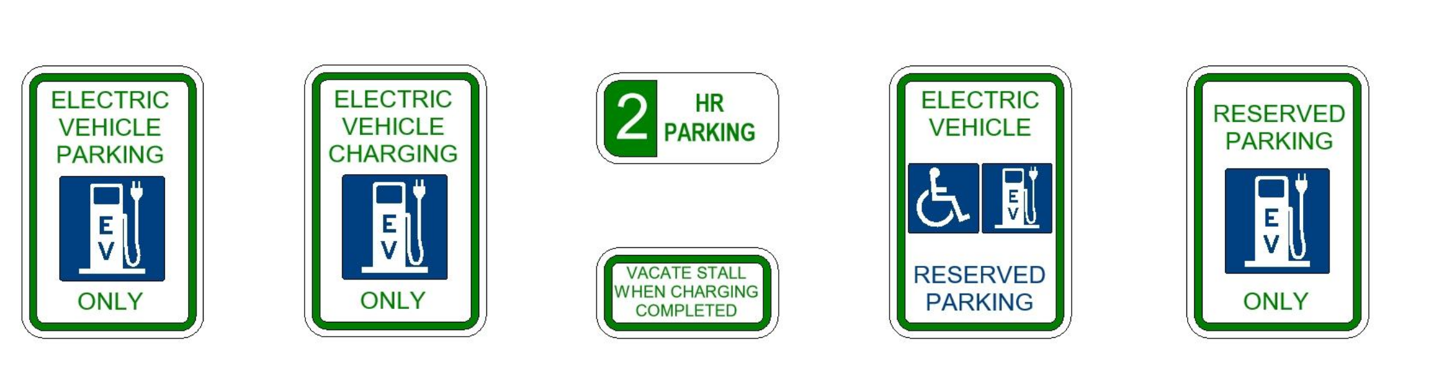

**NCUTCD Proposal on Parking, Standing and Signs**

We recommend approval of the following proposed changes that we understand will be recommended by NCUTCD.

Section 2B.53 Parking, Standing, and Stopping Signs (R7 and R8 Series)

Support:

Parking signs pertain to the parking, stopping, and standing of vehicles along the roadway and in designated parking areas. They cover a wide variety of regulations, and only general guidance can be provided here.

The word “standing” when used on the R7 and R8 series of signs refers to the practice of a driver keeping the vehicle in a stationary position while continuing to occupy the vehicle.

Local agency codes may distinguish active loading, active passenger loading and/or waiting. The word “stopping” when used on the R7 and R8 series signs refers to any vehicle, occupied by a driver or not, that stops.

Parking signs are categorized as either (1) prohibiting parking or (2) permissive~~permitting~~ parking with restrictions on how parking is allowed. They are further categorized as either parking (R7 series) signs or emergency parking (R8 series) signs.

The types of parking prohibitions that might be encountered include, but are not limited to parking, standing or stopping being:

1. ~~Parking, standing, or stopping is~~ Prohibited at all times.
2. ~~Parking, standing, or stopping is~~ Prohibited only certain times of the day and/or days of the week.
3. ~~Parking, standing, or stopping is~~ Prohibited with exceptions, such as for bus stops, loading/unloading zones, persons with disabilities, or electric vehicle charging stations.
4. ~~Parking, standing, or stopping is~~ Prohibited under certain conditions or events, such as Snow Emergency Routes.

Permissive parking signs allowing parking with restrictions include, but are not limited to:

1. Parking only allowed for limited time duration, such as 30 minutes, 1 hour, etc.
2. Metered parking requiring payment at an individual or a multi-space parking meter, or through electronic means such as by telephone or mobile application.
3. Reserved parking for ~~persons with disabilities or patrons or employees of a business~~ select vehicle types such as vehicles of persons with disabilities, electric charging, police/government vehicles, motorcycles, bicycles, valet, taxi stands (vehicle pedicab, horse drawn), carpools, car sharing, emergency parking and others.
4. Angled or back-in angled parking when it is not commonly utilized in the area.
5. Parking programs such as neighborhood/residential permits, school areas, or special events.

**NCUTCD Proposal for Use of “BLUE P” for Identification of Parking Facilities**

We support, indeed strongly recommend, adoption of the so-called Blue P for designation of parking facilities location by the NCUTCD. We understand that it may not have been submitted in time for incorporation in the NPA. However, we strongly support this proposal and would support its inclusion in the 11th Edition. The proposal is identified by the NCUTD as follows:

|  |  |
| --- | --- |
| **TECHNICAL COMMITTEE:** | **GMI Technical Committee** |
| **ITEM NUMBER:** | 20A-GMI-01 |
| **TOPIC:** | Publicly Accessible Off-Street Parking General Service Signs |
| **ORIGIN OF REQUEST:** | Resubmission of ITE Parking Council Concept from 2008 with support of International Parking and Mobility Institute, ITE Parking Council and RWSTC Parking Task Force |
| **AFFECTED SECTIONS  OF MUTCD:** | Section 2D.04 Size of Signs  Section 2D.47 Parking Area Guide Sign  Section 2D.50 Community Wayfinding Signs  Section 2I.01 Sizes for General Service Signs  Section 2I.02 General Service Signs for Conventional Roads |

The following is our understanding of the text and details proposed, with a slight edit to use the term “public parking” rather than “publicly accessible parking” to avoid confusion with the now widely understood term “accessible parking” under ADA:

* The design of the sign would be a white font and circle using an E-modified font with a blue background (pantone 294, within the FHWA blue color box). Character of the “P” and circle should follow Standard Highway Signs that already utilize the P symbol
* Proposed text (clean):

Guidance:

12a1 The parking symbol of a white P on a blue background enclosed in a circular white border (sign over all minimum 24 inch) should be used at the entrance of an off-street, public~~ly accessible~~ parking area.

Option:

12a The Parking (D9-XX) sign (see Figure 2I-1), with accompanying Advanced Turn and Directional Arrow Auxiliary signs, may be installed on approach routes to show the direction to nearby publicly accessible parking areas. For large parking areas, the Parking (D9-XX) sign may be supplemented with a parking facility name or logo and may include a changeable message sign element showing the number of available spaces and/or parking fee with a letter height for numeric digits of at least six inches.

12b The Parking (D9-XX) sign may be supplemented by an educational plaque placed below the D9-XX sign.

Add Sign D9-XX

Add Plaque D9-XXP

Note as Optional

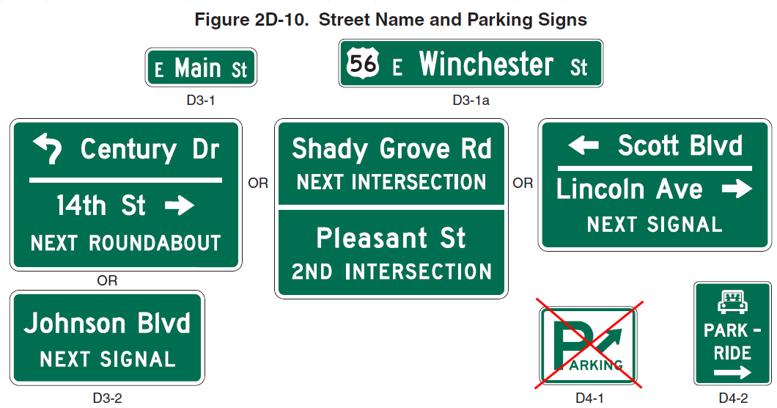

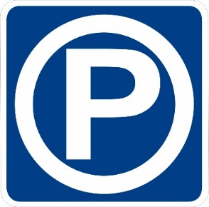

Commentary: MUTCD signs for parking are inconsistent; the following are currently used in MUTCD for parking:

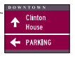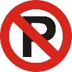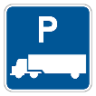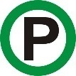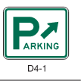

The Blue P is already recognized in MUTCD to stand for Parking, but the 2009 P with green circle is dropped in the 2020 NPA. D4-1 is frankly hideous, which discourages its use, particularly on SROPT. The Blue P is widely adopted and used throughout the world as seen in the compilation below.



Image courtesy NCUTCD

As parking professionals, we find use of Blue P increasingly important with architectural treatments of parking structures that seek to have the building blend into the urban fabric and thus parking structures may not be easily recognizable as parking facilities.

We believe that many are already using the Blue P for parking quite successfully. For example, the City of Minneapolis uses it on all of their public parking facilities, and encourages private properties to use it as well. As a result, it is widely used in the City as seen in a few photos below.

Other places where it has been used are below:

